Pies Nutritional Information

APPLE
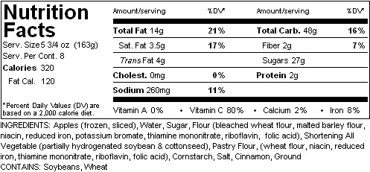

Key Lime
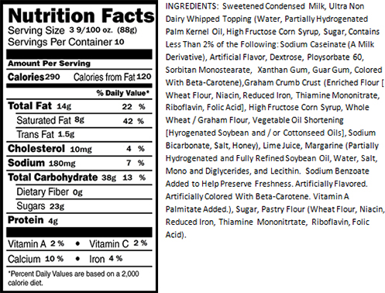

PECAN
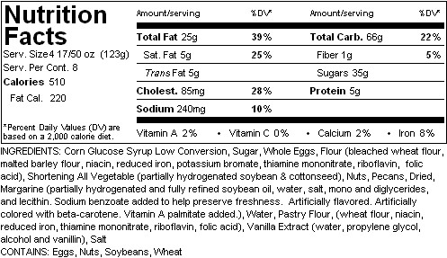

FRENCH SILK CHOCOLATE PIE
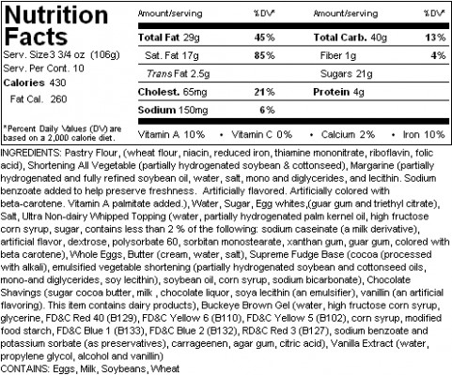

CANDY BAR PIE WITH BUTTERFINGER ® CANDY BARS
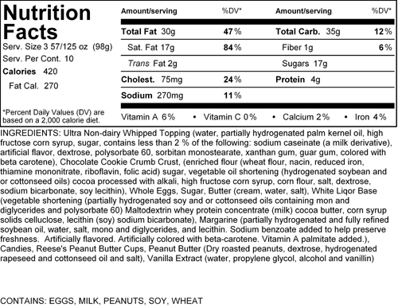

PEANUT BUTTER CUP PIE WITH REESES ® PEANUT BUTTER CUPS
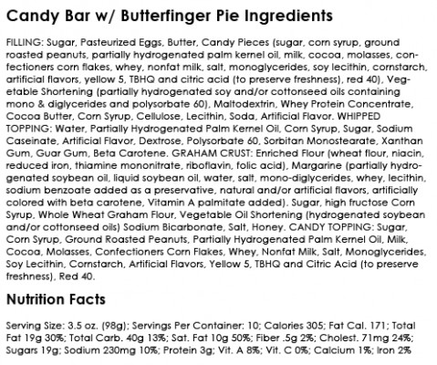

PUMPKIN
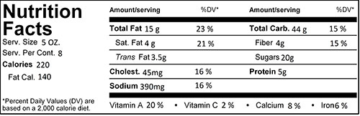
Ingredients:
Milk (grade A milk and vitamin 3D), pumpkin pie mix, canned, sugar, flour (bleached wheat flour, malted barley flour, niacin, reduced iron, potassium bromate, thiamine mononitrate, riboflavin, folic acid), shortening, all vegetable ( partially hydrogenated soybean & cottonseed), whole eggs, water, pastry flour, (wheat flour, niacin, reduced iron, thiamine mononitrate, riboflavin, folic acid), salt, cinnamon, ground pumpkin pie spice (cinnamon, allspice ginger, imitation mace, and cloves)
Contains: wheat, soy, milk & eggs

PEACH
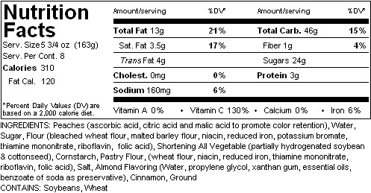

STRAWBERRY-RHUBARB
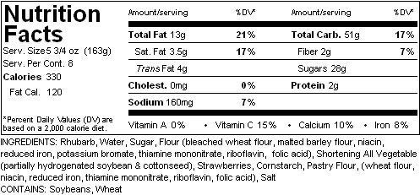

CHERRY
